Practical - 1
Practical Title: Project Initiation, Requirement Analysis, Sitemap, Wireframe, and GitHub Setup

Problem Definition: Initiate the semester-long StudentHub portal by identifying the problem scope, user roles, key modules, navigation flow, and minimum 10 pages. Create a sitemap, low-fidelity wireframe, project folder structure, README file, and GitHub repository.

Theory

What is URL and parts of URL?
Answer: A uniform resource locator is the address your browser uses to find a resource on the internet. It tells the browser where something lives online and how to reach it.
URL consists of:
- Protocol or scheme
- Domain name
- Subdomain
- Path
- Query parameters
- Anchor or fragment
Reference Link: https://www.networksolutions.com

How does HTML file process in web browser?
Answer: HTML file -> DNS Lookup -> TCP Connection -> TLS Handshake ->
HTTP Request -> Serve Processing -> HTTP Response -> Rendering Back Response

3. How will page navigation flow managed among all HTML pages?
Answer: HTML Pages navigation flow is managed by HTML sitemap which is the simple webpage that lists links to all the pages of a website in the structured manner allowing users to navigate through the site more easily.

4. How will GitHub commits be maintained after each practical?
Answer: GitHub commits should be maintained using structured commits, clear messages, and organized branches to ensure a clean, traceable history for each practical.

Implementation/ Output/Result
Learning
- Learned how to identify the problem scope and requirements of the StudentHub Portal.
- Understood the different user roles and their requirements.
- Learned to identify and organize the key modules and features of the portal.
- Learned how to create a proper navigation flow and sitemap for the website.
- Understood how to design a low-fidelity wireframe before actual development.
- Learned how to create a proper project folder structure for better organization.
- Learned how to write a README file to document the project.
- Understood the basics of Git and GitHub for storing and managing project files.
- Learned how proper planning and documentation help in developing a semester-long project.

Evidence of Work (Screenshots)
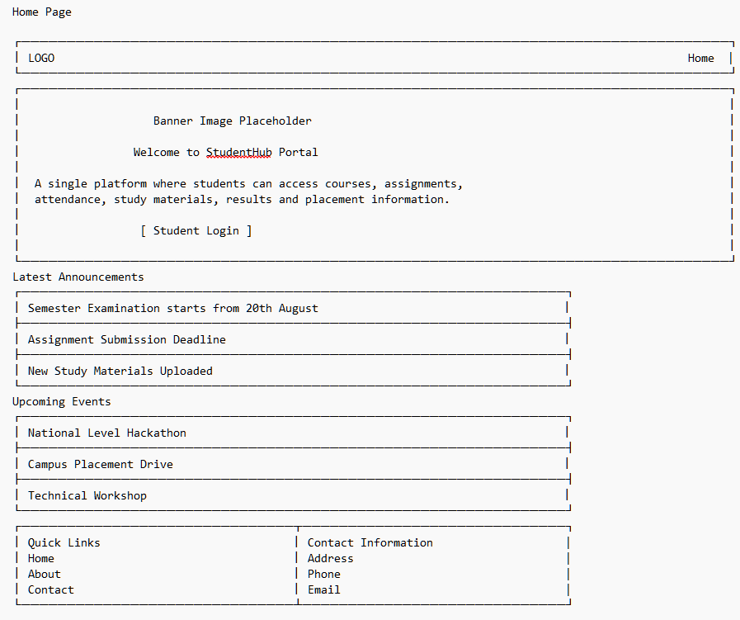
Figure 1.1: Home Page Wireframe
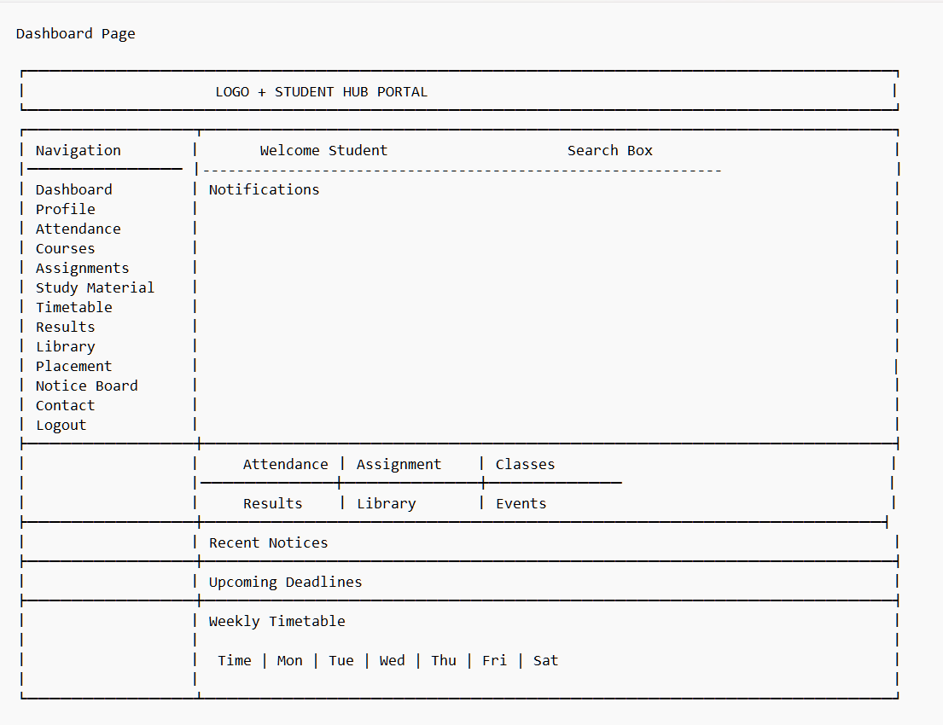
Figure 1.2: Dashboard Page Wireframe
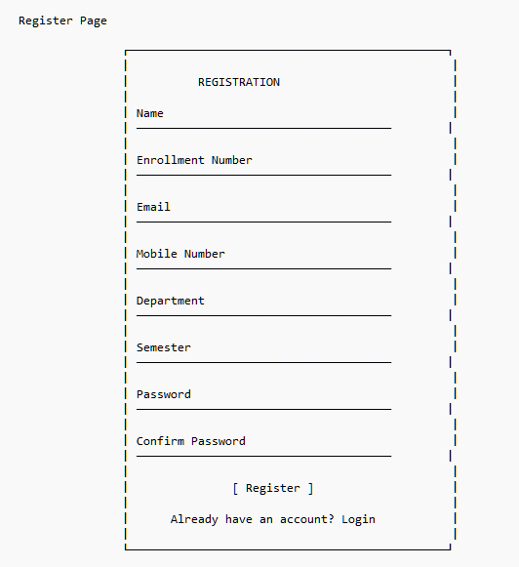
Figure 1.3: Register Page Wireframe
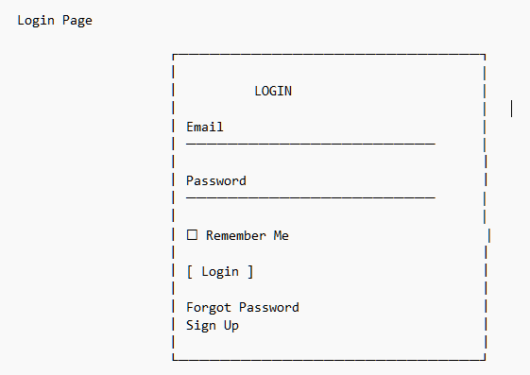
Figure 1.4: Login Page Wireframe
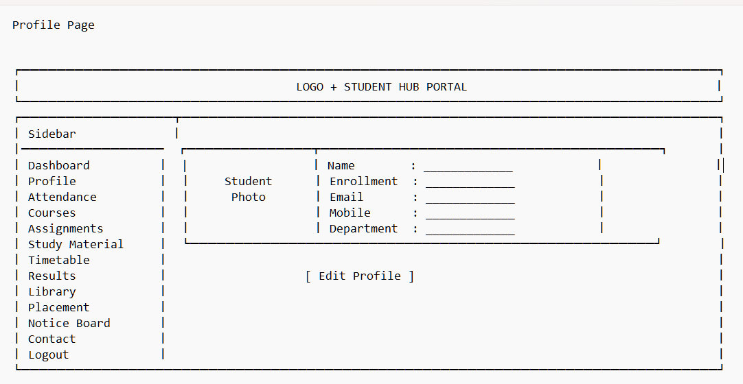
Figure 1.5: Profile Page Wireframe
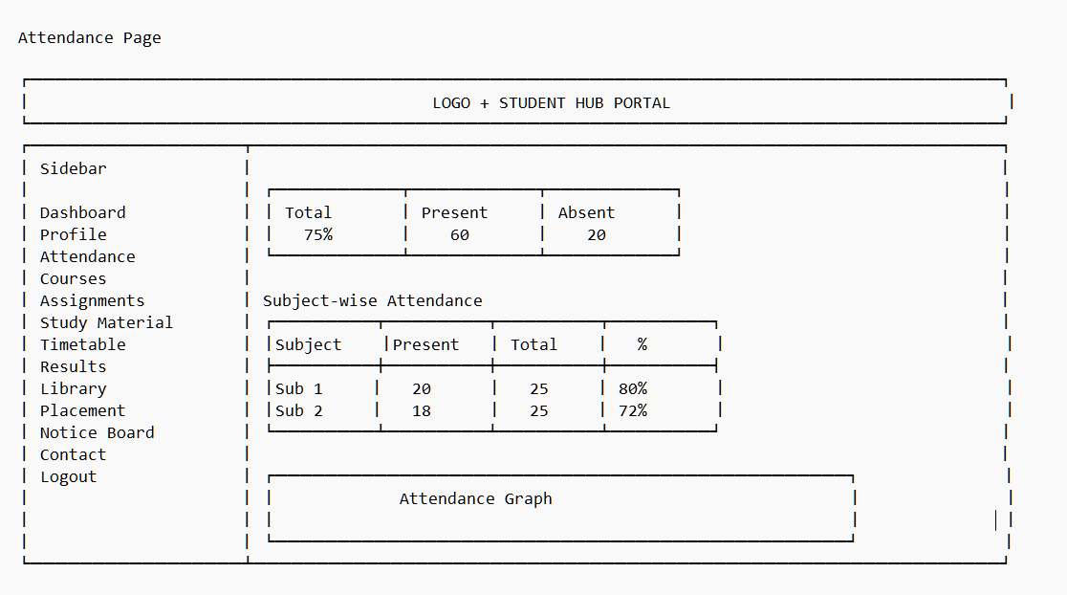
Figure 1.6: Attendance Page Wireframe
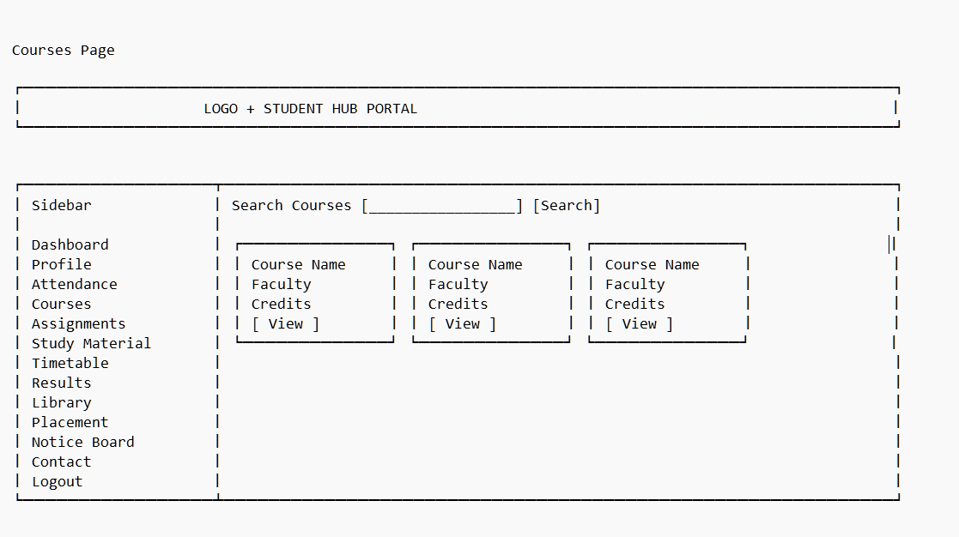
Figure 1.7: Courses Page Wireframe
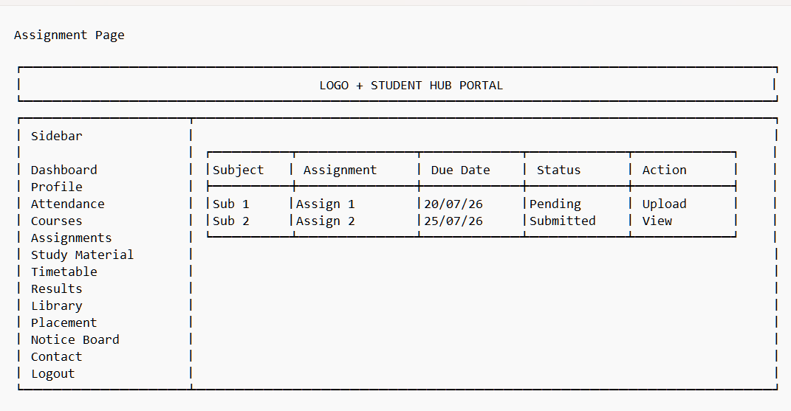
Figure 1.8: Assignment Page Wireframe
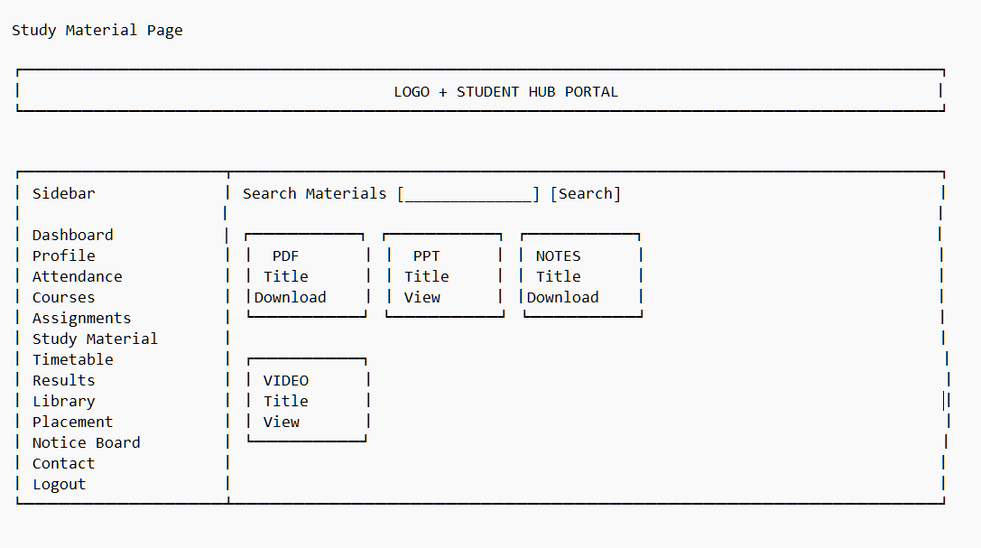
Figure 1.9: Study Material Page Wireframe
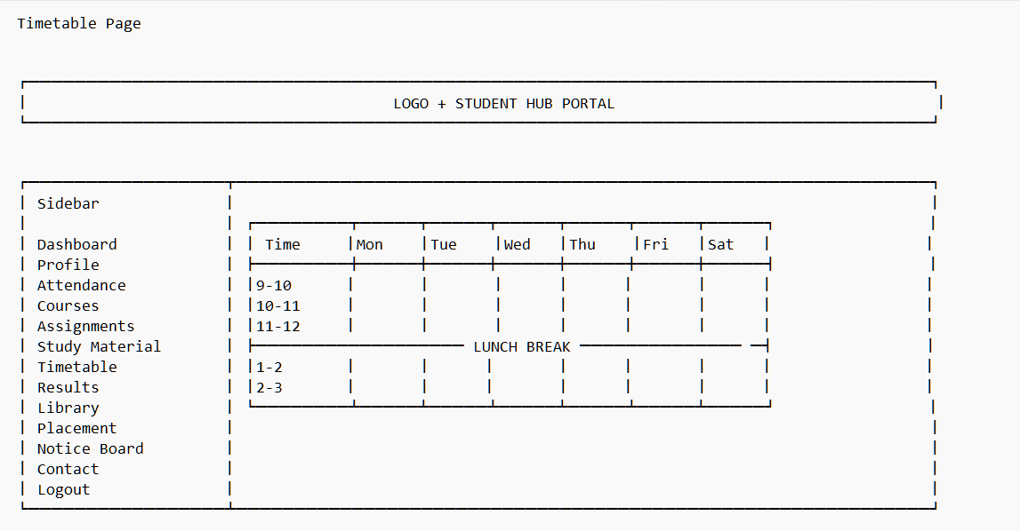
Figure 1.10: Timetable Page Wireframe
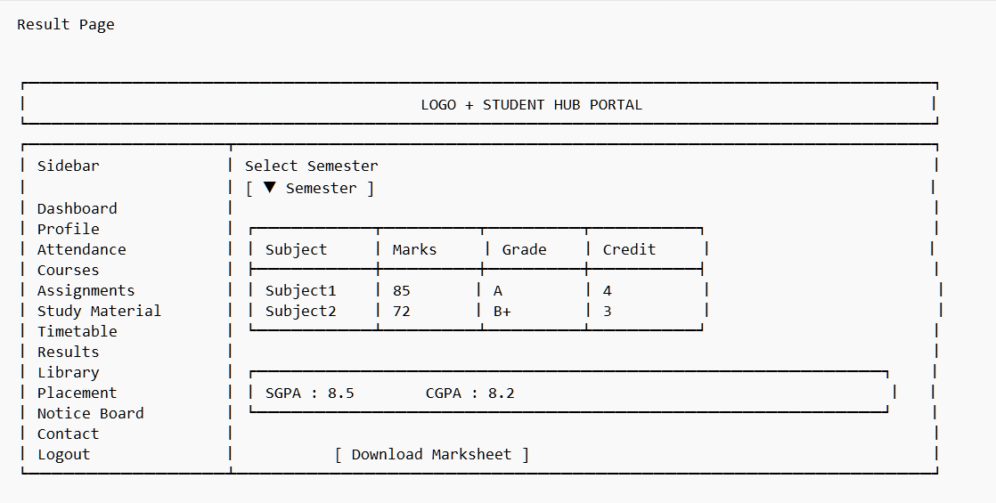
Figure 1.11: Result Page Wireframe
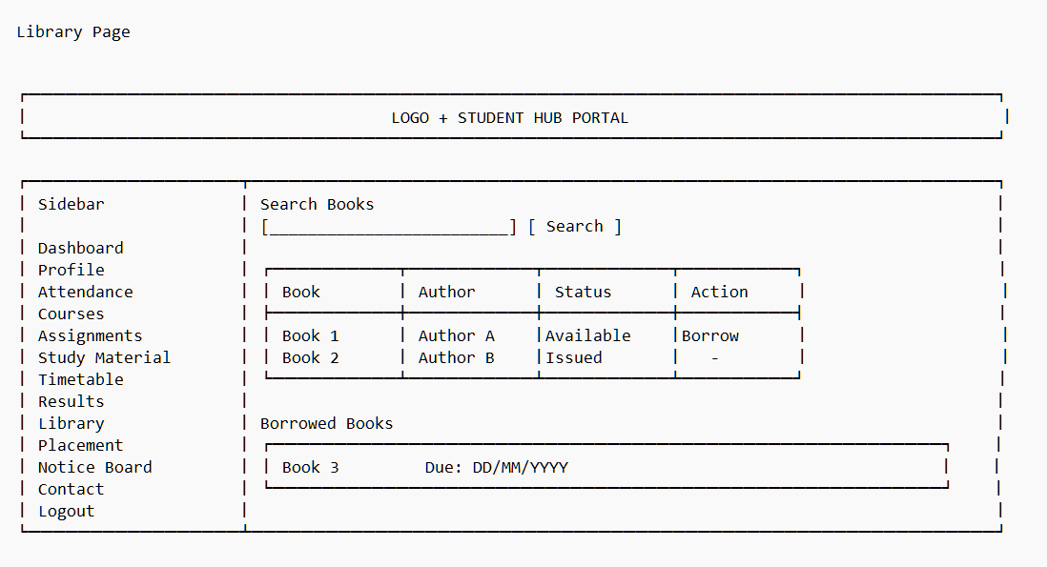
Figure 1.12: Library Page Wireframe

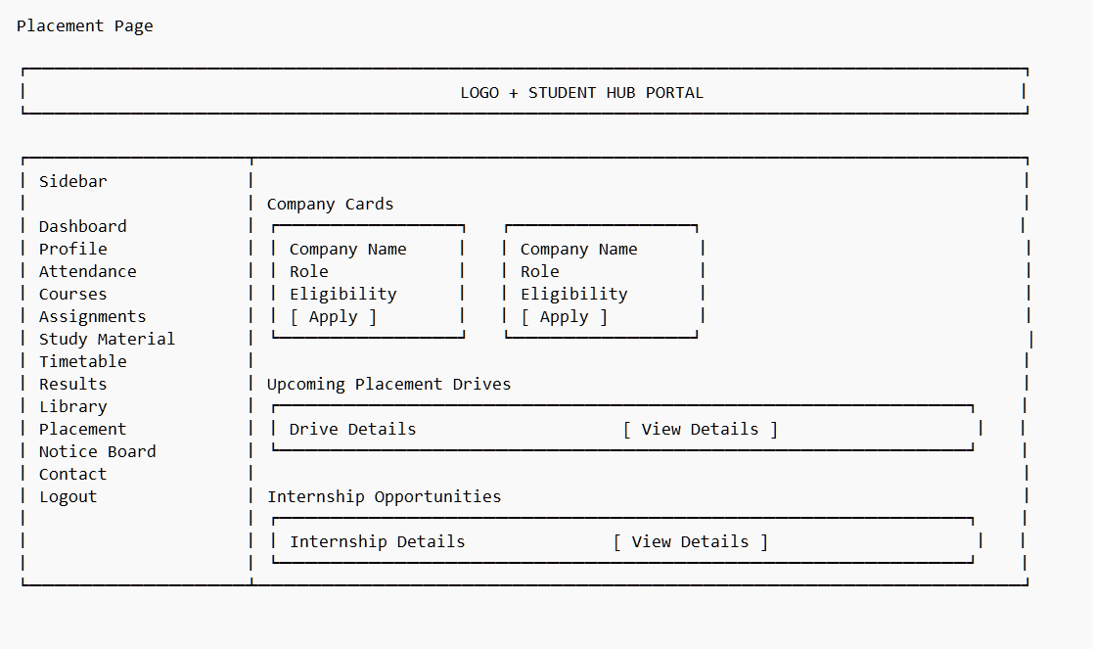
Figure 1.13: Placement Page Wireframe
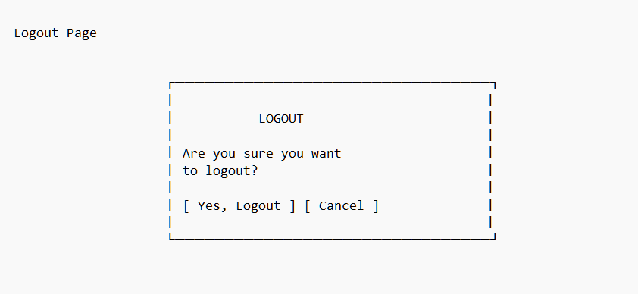
Figure 1.14: Logout Page Wireframe

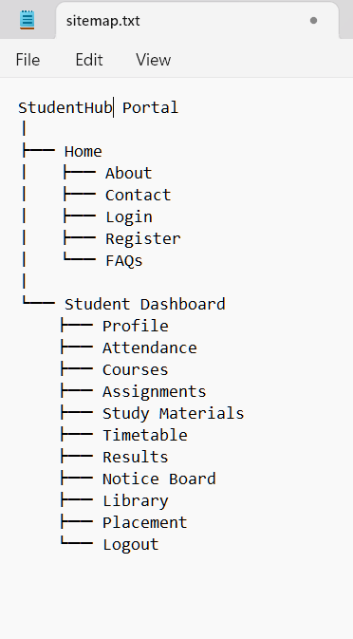
Figure1.15: Sitemap

GitHub Repository Link: https://github.com/shahmahi0717/Student-Hub-Portal

Challenges Faced:
- Identifying the proper project scope and requirements.
- Deciding the required modules and pages.
- Creating a clear sitemap and navigation flow.
- Designing the wireframe properly.
- Organizing the project folder structure.
- Setting up and managing the GitHub repository.

Learning Outcomes:

- Learned to plan and structure a web project.
- Understood how to identify user roles and requirements.
- Learned to create a sitemap and wireframe.
- Improved skills in project organization and documentation.
- Learned the basics of GitHub and version control.
- Developed better understanding of website navigation and module planning.

Faculty Remarks: (Keep this blank for faculty)

